General Practice Data for Planning and Research: GP Practice Privacy Notice
How and why general practice shares your data with NHS Digital for planning and research.
Page contents

- Top of page
- Purpose of this privacy notice
- About the General Practice Data for Planning and Research data collection
- How sharing patient data with NHS Digital helps the NHS and you
- What data is shared about you with NHS Digital
- The data we share
- Opting out
- Our legal basis for sharing data with NHS Digital
- More information on NHS Digital and this collection

We are providing data to NHS Digital as part of the General Practice Data for Planning and Research data collection, so that patient data can be used to help improve everyone's health and care.
Purpose of this privacy notice
Under data protection law we must tell you about how we use your personal information. This includes the personal information that we share with other organisations and why we do so. Our main GP practice privacy notice is on our website. This additional privacy notice provides details about the personal information that we are sharing with NHS Digital for its General Practice Data for Planning and Research data collection.
NHS Digital is part of the NHS. It collects, analyses, publishes and shares data to improve everyone’s health and care. Read more about NHS Digital.
We use the term patient data to refer to personal information in the rest of this notice.

About the General Practice Data for Planning and Research data collection
https://youtu.be/YLi9gh7RyLA

How sharing patient data with NHS Digital helps the NHS and you
The NHS needs data about the patients it treats in order to plan and deliver its services and to ensure that care and treatment provided is safe and effective. The General Practice Data for Planning and Research data collection will help the NHS to improve health and care services for everyone by collecting patient data that can be used to do this. For example patient data can help the NHS to:
- monitor the long-term safety and effectiveness of care
- plan how to deliver better health and care services
- prevent the spread of infectious diseases
- identify new treatments and medicines through health research
GP practices already share patient data for these purposes, but this new data collection will be more efficient and effective.
We have agreed to share the patient data we look after in our practice with NHS Digital who will securely store, analyse, publish and share this patient data to improve health and care services for everyone. This includes:
- informing and developing health and social care policy
- planning and commissioning health and care services
- taking steps to protect public health (including managing and monitoring the coronavirus pandemic)
- in exceptional circumstances, providing you with individual care
- enabling healthcare and scientific research
This means that we can get on with looking after our patients and NHS Digital can provide controlled access to patient data to the NHS and other organisations who need to use it to improve health and care for everyone.
Contributing to research projects will benefit us all as better and safer treatments are introduced more quickly and effectively without compromising your privacy and confidentiality.
NHS Digital has engaged with the British Medical Association (BMA), Royal College of GPs (RCGP) and the National Data Guardian (NDG) to ensure relevant safeguards are in place for patients and GP practices.

What data is shared about you with NHS Digital
This data will be shared from 1 July 2021. Data may be shared from the GP medical records about:
- any living patient registered at a GP practice in England when the collection started - this includes children and adults
- any patient who died after this data sharing started, and was previously registered at a GP practice in England when the data collection started
We will not share your name or where you live. Any other data that could directly identify you, for example your NHS number, General Practice Local Patient Number, full postcode and date of birth, is replaced with unique codes which are produced by de-identification software before the data is shared with NHS Digital.
This process is called pseudonymisation and means that no one will be able to directly identify you in the data. The diagram below helps to explain what this means. Using the terms in the diagram, the data we share would be described as de-personalised.
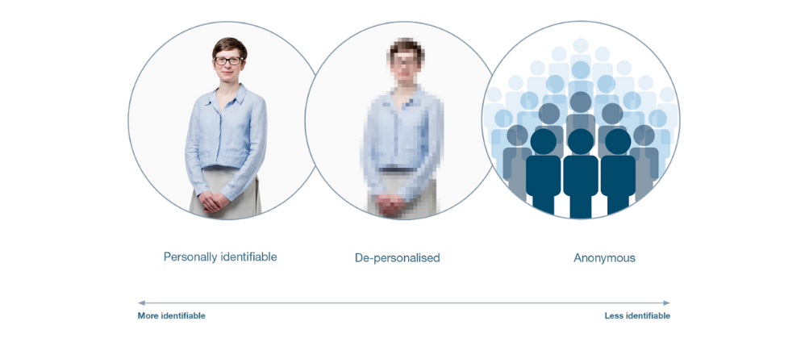
Image provided by Understanding Patient Data under licence.
NHS Digital will be able to use the same software to convert the unique codes back to data that could directly identify you in certain circumstances, and where there is a valid legal reason. Only NHS Digital has the ability to do this. This would mean that the data became personally identifiable data in the diagram above. An example would be where you consent to your identifiable data being shared with a research project or clinical trial in which you are participating, as they need to know the data is about you.
For more information about when NHS Digital may be able to re-identify the data, and how NHS Digital will use your data see the NHS Digital General Practice Data for Planning and Research Transparency Notice.

The data we share
We will share structured and coded data from GP medical records that is needed for specific health and social care purposes explained above.
Data that directly identifies you as an individual patient, including your NHS number, General Practice Local Patient Number, full postcode, date of birth and if relevant date of death, is replaced with unique codes produced by de-identification software before it is sent to NHS Digital. This means that no one will be able to directly identify you in the data.
NHS Digital will be able to use the software to convert the unique codes back to data that could directly identify you in certain circumstances, and where there is a valid legal reason. This would mean that the data became personally identifiable in the diagram above. It will still be held securely and protected, including when it is shared by NHS Digital.
We will share:
- data on sex, ethnicity and sexual orientation
- clinical codes and data about diagnoses, symptoms, observations, test results, medications, allergies, immunisations, referrals, recalls and appointments, including information about your physical, mental and sexual health
- data about staff who have treated you
More detailed information about the patient data we collect is contained in the Data Provision Notice issued to GP practices.
What is not shared:
- your name and address (except your postcode in unique coded form)
- written notes (free text), such as the details of conversations with doctors and nurses
- images, letters and documents
- coded data that is not needed due to its age - for example medication, referral and appointment data that is over 10 years old
- coded data that we are not permitted to share by law - for example certain codes about IVF treatment, and certain information about gender reassignment

Opting out
If you don’t want your identifiable patient data (personally identifiable data in the diagram above) to be shared for purposes except for your own care, you can opt-out by registering a Type 1 Opt-out or a National Data Opt-out, or both. These opt-outs are different and they are explained in more detail below. Your individual care will not be affected if you opt out using either option.
Type 1 Opt-out (opting out of NHS Digital collecting your data)
If you do not want your identifiable patient data (personally identifiable data in the diagram above) to be shared outside of the GP practice for purposes except your own care, you can register an opt-out with the GP practice. This is known as a Type 1 Opt-out.
Type 1 Opt-outs were introduced in 2013 for data sharing from GP practices, but may be discontinued in the future as a new opt-out has since been introduced to cover the broader health and care system, called the National Data Opt-out. If this happens, patients who have registered a Type 1 Opt-out will be informed. There is more information about National Data Opt-outs below.
NHS Digital will not collect any patient data for patients who have already registered a Type 1 Opt-in line with current policy. If this changes patients who have registered a Type 1 Opt-out will be informed.
If you do not want your patient data shared with NHS Digital for the purposes above, you can register a Type 1 Opt-out with your GP practice. You can register a Type 1 Opt-out at any time. You can also change your mind at any time and withdraw a Type 1 Opt-out.
Data sharing with NHS Digital will start on 1 July 2021.
If you have already registered a Type 1 Opt-out with your GP practice your data will not be shared with NHS Digital.
If you wish to register a Type 1 Opt-out with your GP practice before data sharing starts with NHS Digital, this should be done by returning this form to your GP practice by 23 June 2021 to allow time for processing it. If you have previously registered a Type 1 Opt-out and you would like to withdraw this, you can also use the form to do this. You can send the form by post or email to your GP practice or call 0300 3035678 for a form to be sent out to you.
If you register a Type 1 Opt-out after your patient data has already been shared with NHS Digital, no more of your data will be shared with NHS Digital. NHS Digital will however still hold the patient data which was shared with them before you registered the Type 1 Opt-out.
If you do not want NHS Digital to share your identifiable patient data (personally identifiable data in the diagram above) with anyone else for purposes beyond your own care, then you can also register a National Data Opt-out. There is more about National Data Opt-outs and when they apply below.
National Data Opt-out (opting out of NHS Digital sharing your data)
This applies to identifiable patient data about your health (personally identifiable data in the diagram above), which is called confidential patient information. If you don’t want your confidential patient information to be shared by NHS Digital with other organisations for purposes except your own care - either GP data, or other data it holds, such as hospital data - you can register a National Data Opt-out.
If you have registered a National Data Opt-out, NHS Digital won’t share any confidential patient information about you with other organisations, unless there is an exemption to this, such as where there is a legal requirement or where it is in the public interest to do so, such as helping to manage contagious diseases like coronavirus. You can find out more about exemptions on the NHS website.
From 1 October 2021, the National Data Opt-out will also apply to any confidential patient information shared by the GP practice with other organisations for purposes except your individual care. It won’t apply to this data being shared by GP practices with NHS Digital, as it is a legal requirement for us to share this data with NHS Digital and the National Data Opt-out does not apply where there is a legal requirement to share data.
You can find out more about and register a National Data Opt-out, or change your choice on nhs.uk/your-nhs-data-matters or by calling 0300 3035678.

Our legal basis for sharing data with NHS Digital
When we share patient data, there are strict laws in place that we must follow. Under the UK General Data Protection Regulation (GDPR), this includes explaining to you what legal provisions apply under GDPR that allow us to share the data. The GDPR protects everyone's data.
Read more about the legal basis for sharing GP data for planning and research
The Health and Social Care Act 2012 (2012 Act) covers the sharing and collection of health and care data. It says that when the Secretary of State for Health and Social care needs to collect and analyse data to help the health service, they can tell NHS Digital to do this for them. This instruction, which NHS Digital must act on, is called a direction. When NHS Digital asks health and care organisations for data it needs, in order to comply with a direction, they are legally required under the 2012 Act to share it with NHS Digital.
In this case:
- The Secretary of State for Health and Social Care sent a direction to NHS Digital, instructing them to collect and analyse general practice data for health and social care purposes including policy, planning, commissioning, public health and research purposes. You can read this direction: General Practice Data for Planning and Research Directions 2021.
- NHS Digital then sent GP practices a document called a data provision notice, giving details of the data it needs GP practices to share so it can comply with the direction. All GP practices in England are legally required to share data with NHS Digital when they are sent a data provision notice. You can read the data provision notice: General Practice Data for Planning and Research Data Provision Notice.
Under data protection law, we can only share patient data if we have a legal basis under Articles 6 and 9 of the GDPR.
Our legal basis for sharing patient data with NHS Digital is Article 6(1)(c) - legal obligation, as we are required under the 2012 Act to share it with NHS Digital.
When we are sharing patient data about health we also need a legal basis under Article 9 of the GDPR.
This is:
- Article 9(2)(g) – as we are sharing patient data for reasons of substantial public interest, for the purposes of NHS Digital exercising its statutory functions under the General Practice Data for Planning and Research Directions. It is substantially in the public interest to process patient data for planning and research purposes to improve health and care services for everyone. This is permitted under paragraph 6 of Schedule 1 of the Data Protection Act 2018 (DPA).
- Article 9(2)(h) – as we are sharing patient data for the purposes of providing care and managing health and social care systems and services. This is permitted under paragraph 2 of Schedule 1 of the DPA.
- Article 9(2)(i) - as patient data will also be used for public health purposes. This is permitted under paragraphs 3 of Schedule 1 of the DPA.
- Article 9(2)(j) - as patient data will also be used for the purposes of scientific research and for statistical purposes. This is permitted under paragraph 4 of Schedule 1 of the DPA.

More information on NHS Digital and this collection
You can read more about how NHS Digital uses the patient data we share with them in the NHS Digital General Practice Data for Planning and Research Transparency Notice.
You can read more about how we use and share your personal information, your choices and rights in our main GP Practice Privacy Notice on our website.

